
Lab 3
Date 11/20/25
CSIS 3700 Lab
Aidan Dudash

: Goals/Objectives

The goal of this project is to turn a small set of rover text files into a consistent, end-to-end reasoning pipeline without hiding any of the logic. The program ingests one or more SOL data files, an MSL assertion file (msl_assertion.txt), and an argument file (argument.txt). From the measurement side it normalizes units with a shared Unit/Measurement layer, composes daily navigation vectors, maintains streaming temperature statistics, and classifies SHERLOC/SUPERCAM spectral samples into band–intensity labels under the given per-SOL and global caps (≤1 distance, ≤1 temperature, ≤12 wavelengths per SOL; ≤9 unique classifications; ≤10 stored temperature representatives). All numeric work is orchestrated by Robot, which stays focused on Mars physics and mission summaries, not on the logic itself.
On top of that, the project adds a thin but explicit reasoning layer that mirrors the algebraic and state-machine models 1:1. MSLAssertionLoader parses MSL’s P/Q/R/S/T claims into Proposition objects; PerseveranceBuilder maps the rover summaries (water-related wavelengths, methane/oxygen hints, first-100m behavior, average temperature, etc.) into a parallel set of data-driven propositions; and TruthReconciler resolves the two into a three-valued truth assignment over P–T. Finally, Ratiocinator reads the X/Y/Z argument file, converts each expression into postfix, and evaluates it against that truth table. The objective is not just to meet the file-format and reporting requirements (caps, wavelength bands, intensity thresholds, P–T meanings, and X/Y/Z evaluation), but to do it in a way where every step in the code can be traced directly back to the mathematical and engineering models used to design it.

2.0: Mathematical Model

2.1: IPO Chart
IPO-1 Common I/O
Input | Processing | Output
Program args: list of SOL data file paths (one per Mars year) | Collect measurement paths into a vector<string>; iterate per file; reset per-year context (SOL index, stats, classifiers) before each run | Per-file run status; aggregated measurement error count across all years
Program arg: MSL assertion file path (e.g., msl_assertions.txt) | Store path; open once after all measurement processing; pass stream to Ratiocinator | MSL assertion load status (OK/ERR)
Program arg: Argument file path (e.g., arguments.txt) | Store path; open once after propositions derived; pass stream to Ratiocinator | Argument load status (OK/ERR)
SOL data file (e.g., lab3_sol_data_YYYY.txt) | Open file; sequential read line-by-line | Lexer/Parser status (OK/ERR) for that file
Lines: d (distance), t (temperature), w (wavelength) | Tokenize CSV fields; trim/validate tokens; dispatch to appropriate subsystem | Parsed record objects (DistanceRec, TempRec, WaveRec) per SOL
Numeric values + units (distance: nm–km; time: s–sol; temp: °C/K; λ: nm–m; intensity scalar) | Use Measurement/Unit to normalize to SI (distance to m, time to s, temp to K, λ to m) | Normalized Measurement values for downstream components
SOL index (implicit by file order) | Maintain SOL counter per file; enforce per-SOL max counts (≤1×d, ≤1×t, ≤12×w); track whether each SOL had d/t/w | SOL context {id, hasD, hasT, wCount} per file/year

IPO-2 Navigation
Input | Processing | Output
d record: (distance, unit, direction, time, unit) × up to 4 per SOL | Convert each distance to m and time to s using Measurement/Unit; ignore missing moves if fewer than 4 specified | Up to 4 normalized moves (m, s) with directions
Directions: right/left/forward/backward | Map axes: +x = right, −x = left, +y = forward, −y = backward | Signed components (dx, dy) per move + time
Up to 4 signed components per SOL | Sum per SOL: Fx = Σdx, Fy = Σdy, T = Σtime; compute R = sqrt(Fx² + Fy²) and heading θrad​=atan2(Fy​,Fx​), convert θdeg = θrad * 180 / π | DailyDisplacement{ R[m], θ[deg], T[s], SOL_id }
Per-SOL displacement results (vector/list) | Store one DailyDisplacement per SOL in vector; enforce ≤ 1374 entries across full mission | Navigation history structure respecting memory constraints
Mission-level displacement data | Accumulate totals: total path length, total time; optionally compute distance within first 100 m shell for proposition S | Per-year and overall navigation summary and derived metrics for logical layer
IPO-3 Temperature (REMS)
Input | Processing | Output
t record: temperature value + unit (°C or K) | Normalize each raw reading to Kelvin (K = C + 273.15 if °C) | Per-SOL K value for pipelines
Stream of K values across SOLs (per file/year) | Feed into streaming TemperatureStats: update running mean, streaming median (e.g., two-heap or equivalent), and update top-3 and bottom-3 extremes while only storing up to 10 representative values | TemperatureStats object with Mean(K), Median(K), 3 Highest (asc), 3 Lowest (asc)
SOL index + Mars season map | For each K, map SOL to season (Summer/ Winter); update tracked minima per season | Lowest Summer (K), Lowest Winter (K) per year/file
All TemperatureStats objects (one per input measurement file) | Optionally merge or compare per-year stats; prepare a single mission-level summary if desired | Per-year and mission-level TemperatureStats ready for report and proposition building
Finalization step | Convert summary stats to both °C and K; expose helper queries needed by logical layer (e.g., “is mean temp = −25 °C across mission?” for proposition T) | Dual-unit statistics + boolean hooks for propositions (e.g., isAlwaysMinus25C)

IPO-4 Spectroscopy Samples (SHERLOC/SUPERCAM)
Input | Processing | Output
w record: wavelength + unit (nm–m), intensity (scalar), SOL id | Build Sample{ λ:Measurement, intensity, sol }; normalize λ to m using Measurement/Unit; keep intensity as raw scalar | Sample object with λ normalized to m and raw intensity scalar
Sample(λ, I) | Compute spectral band (UV / Visible / IR) based on λ ranges; store raw intensity with the sample | Classification key like "UV", "VIS", or "IR"
Classification key, SOL | If key not yet seen and unique class count < 9, push {key, sol} into classification stack; otherwise ignore new keys once 9 are reached | Up to 9 unique classifications per mission/file stored in encounter order
Reporting time | Traverse classification stack in reverse (LIFO): last unique class discovered to first in report | List (classification key, first-encounter SOL) in reverse encounter order for report and logical layer (“evidence” propositions P/Q/R)

IPO-5 Reporting
Input | Processing | Output
Aggregated TemperatureStats (per year/file) | For each file/year: format 3 Highest (asc), 3 Lowest (asc), Median (C & K), Mean (C & K), Lowest Winter, Lowest Summer | Report Section A (per year): Temperatures summary
Aggregated SHERLOCK/ SUPERCAM classifications (per year/file) | Return up to 9 unique classification keys with SOL in reverse encounter order | Report Section B (per year): Sample classifications (band + SOL)
Vector/list of navigation results for each SOL (per year/file) | For each SOL with distance: format magnitude (m) and angle (deg), optionally time (s); summarize total distance/time traveled | Report Section C (per year): Navigation / Distance traveled
Proposition truth table for P, Q, R, S, T (MSL and Perseverance) | Format paired truth values per proposition: P MSL = ?, PER = ?, reconciled = ? (true/false/unknown) | Report Section D: P–T proposition comparison summary
Evaluation results for X, Y, Z from Ratiocinator | For each argument: print original logical expression (text) and final truth value (true/false/unknown) | Report Section E: Argument evaluation (X, Y, Z)
All formatted sections for each file/year | Prepend high-level header per run/year; separate runs with blank line or divider | Full logical + measurement layout for rationator_report.txt
Stream to file | Write buffered text sections to rationator_report.txt; handle errors gracefully | Final report file rationator_report.txt on disk

IPO-6 MSL Assertions to Propositions
Input | Processing | Output
MSL assertion file (proposition lines using detected/all/average/not forms) | Open file; read line-by-line; skip comments/blank lines | Raw assertion strings
Assertion line (e.g., Q,detected(water,500)) | Parse leading proposition label (e.g., P, Q, R, S, T); parse predicate form (detected, all, average, or not(...)) and arguments inside parentheses (subject in Subj and numeric parameter such as intensity, distance, or temperature threshold) | Structured Proposition object with fields: label, form, subject(s), predicate(s)
Full set of parsed MSL propositions | Store in Ratiocinator’s vector<Proposition> or equivalent; mark those representing P, Q, R, S, T via label or metadata | MSLPropSet – internal representation of MSL’s claims about P–T and related facts
Validation phase | Ensure each of P, Q, R, S, T is at least once present in MSL set; if missing, mark as unknown or signal non-fatal warning | MSL proposition table ready for reconciliation

IPO-7 Argument File & Ratiocinator
Input | Processing | Output
Argument file (lines defining X, Y, Z in terms of P–T) | Open and read lines; strip whitespace; separate identifier (X/Y/Z) from expression text | Raw infix expressions for X, Y, Z
Infix logical expression (e.g., X = (P & Q) -> ~S) | Tokenize into operands (P–T) and operators (∧, ∨, →, parentheses); validate token sequence | Token stream for expression
Token stream | Use stack-based infix to postfix algorithm to produce postfix expression; store as sequence/vector | Postfix representation for X, Y, Z
Postfix expression + P–T truth table | Evaluate using operand stack: push truth values for P–T; apply operators as they appear | Final truth values for X, Y, Z
Evaluation results | Save results in Ratiocinator for final reporting; optionally provide hooks for debugging/tracing | Truth mapping {X,Y,Z} → {true, false, unknown}

IPO-8 Control & Validation
Input | Processing | Output
Program start | Initialize Planet::Mars(), reset subsystems (Navigation, TemperatureStats, SherlocClassifier, Ratiocinator); set global state to S_INIT & SOL = 0 | Ready state
Each measurement input file (outer loop) | Reset per-SOL counters, TemperatureStats, SherlocClassifier, navigation accumulator, SOL index; set state to “processing measurements for this file” | Clean per-year/file state
Each measurement line (inner loop) | Dispatch by leading token (d/t/w); enforce per-SOL counts; when SOL changes or file ends, finalize that SOL’s distance/temperature/samples | Consistent per-SOL records; no more than 1 d, 1 t, 12 w per SOL
Measurement edge cases | Missing d to no distance stored for SOL; missing t to skip temp; w count > 12, ignore extras; empty file to skip without crash | Deterministic, spec-compliant measurement behavior
Parse / unit / range errors in measurement files | Log and skip bad record; do not crash; increment per-file and global error counts; fall back to S_ERROR if constraints violated | Robust run; optional debug log or summary of errors
MSL assertion file | After all measurement files processed, call Ratiocinator: validate syntax, build Proposition objects; on failure, set system state S_ERROR | MSL assertion subsystem ready or error flagged
Propositions from Perseverance measurements | Ratiocinator queries Navigation/Temperature/SHERLOC/SUPERCAM summaries to construct P, Q, R, S, T; reconcile with MSL to assign truth/unknown | Internal truth table for P–T populated
Argument file | Ratiocinator parses X, Y, Z; verify all referenced identifiers are in {P,Q,R,S,T} | Parsed argument expressions or error
Argument evaluation | Ratiocinator run stack-based infix to postfix evaluation using previously computed truth table for P–T | Truth values for X, Y, Z or evaluation error
Finalization | If no fatal errors, generate and write rationator_report.txt; if any stage failed, emit error summary instead | Successful report or an explicit error report

2.2: Finite State Machine
2.2.1: Finite State Table

FST-1 System Level
State | Description | Entry Action | Exit Condition / Transition | Next State
S1 – Program start; prepare runtime | Program is launched; runtime and high-level objects are created | Parse command-line args; collect measurement file paths; store paths for MSL assertion file and argument file; clear global error counters | All required paths resolved and accessible | S2 – Open first SOL data file
S2 – Open first SOL data file | Begin ingesting the first SOL data file for this run | Open the first measurement file; if present, reset mission-level aggregates | File opened successfully | S3 – Process SOL data file (subcycle)
S3 – Process SOL data file (subcycle) | Read and process a single SOL data file, one SOL/line at a time | Enter measurement subcycle FST; initialize per-file navigation, temperature, and sample subsystems | End-of-file reached with no fatal violation | If more files remain, S4 – Open next SOL data file; if no files remain, S5 – Close data ingestion
S4 – Open next SOL data file | Move to the next SOL data file in the program’s list | Advance file index; attempt to open next measurement file; reset per-file statistics | File opened successfully | S3 – Process SOL data file (subcycle)
S5 – Close data ingestion; compute summary stats | All measurement files have been ingested | Finalize mission-level navigation totals, temperature stats, and sample classifications across all years/files | Measurement summaries ready (no fatal errors flagged) | S6 – Load MSL assertions
S6 – Load MSL assertions | Ingest the MSL Horn-clause assertion file into the Ratiocinator | Open assertion file; read each line; parse into Proposition objects; identify entries corresponding to P, Q, R, S, T | File parsed successfully and required propositions identified or defaulted | S7 – Derive Perseverance propositions
S7 – Derive Perseverance propositions | Produce P, Q, R, S, T from Perseverance data and reconcile with MSL | Query navigation, temperature, and sample summaries; construct Perseverance propositions for P–T; compare with MSL propositions; assign reconciled truth values | All P–T truth values determined according to project rules | S8 – Load argument file (X, Y, Z)

S8 – Load argument file (X, Y, Z) | Ingest the logical arguments constructed from P–T | Open argument file; for each of X, Y, Z, read infix expression; tokenize identifiers and operators; store internal representation | All three arguments parsed and only P–T referenced | S9 – Evaluate arguments with Ratiocinator
S9 – Evaluate arguments with Ratiocinator | Compute the truth of X, Y, Z from P–T | Convert infix expressions to postfix using stack algorithm; evaluate each using the reconciled truth table for P–T; store X/Y/Z truth values | All arguments evaluated without error | S10 – Generate rationator_report.txt
S10 – Generate rationator_report.txt | Build the final report combining numeric and logical results | Open output stream; write temperature summary, navigation summary, sample classifications, P–T truth table, and X/Y/Z results; close file | All sections written successfully to rationator_report.txt | S11 – Normal termination
S11 – Normal termination | Program has completed successfully | Optionally print final status to console; release resources | — | S11 – Normal termination (absorbing)
S_E – Fatal error state | Unrecoverable problem; program should not continue normal processing | Log error, including source state (file open failure, malformed assertions, impossible constraints, etc.); skip remaining processing steps | After logging, any further transitions are treated as no-ops for core logic | S_E – Fatal error state (absorbing)

FST-2 Measurement Sub-Cycle (S3, Per File / Per SOL)
State | Description | Entry Action | Exit Condition / Transition | Next State
SC1 – Establish SOL context | Start or reset the per-SOL view for this file | If first SOL, set solIndex = 0; otherwise increment solIndex; clear per-SOL flags (hasD, hasT, wCount); clear SOL-local navigation accumulators | Ready to read first record for this SOL | SC2 – Get next non-empty, non-comment line
SC2 – Get next non-empty, non-comment line | Fetch the next line of data from the current file | Read line from stream; skip blank lines and comments | Valid data line read | SC3 – Route record to subsystem
SC2 – Get next non-empty, non-comment line | Fetch the next line of data from the current file | Read line from stream; skip blank lines and comments | End-of-file reached | SC6 – Commit per-SOL results
SC3 – Route record to subsystem | Decide whether this is a distance, temperature, or wavelength record | Tokenize CSV; validate field count and leading token; classify as d, t, or w | Tokens valid and classified | SC4 – Apply the record
SC3 – Route record to subsystem |  |  | Tokenization or basic validation fails | SC_E – Recoverable parse/validation issue

SC4 – Apply the record | Update the appropriate subsystem with this record | For d: normalize d and t, update nav accumulator, set hasD = true. For t: normalize temp, feed into temp stats, set hasT = true. For w: if wCount < 12, normalize λ, classify sample, feed classifier, increment wCount; else ignore extra w. | Per-SOL limits respected and record successfully applied | SC5 – Decide to keep reading this SOL or end it
SC5 – Decide to keep reading this SOL or end it | Determine whether more records belong to this SOL | Apply design rule for SOL boundaries (e.g., one SOL per logical group or per line index); optionally use explicit SOL markers if present | Boundary detected (last record for this SOL) | SC6 – Commit per-SOL results
SC5 – Decide to keep reading this SOL or end it | Determine whether more records belong to this SOL |  | No boundary detected; still within the same SOL | SC2 – Get next non-empty, non-comment line
SC6 – Commit per-SOL results | Finalize navigation, temperature, and sample results for the current SOL | Compute net displacement for this SOL; record daily distance/time; mark SOL index and whether it had d/t/w; push any new SHERLOCK/SUPERCAM classifications into mission-level stack if appropriate | EOF just processed for this file | SC7 – Close data ingestion for this file
SC6 – Commit per-SOL results |  |  | More data remain in file | SC1 – Establish SOL context (for next SOL)
SC7 – Close data ingestion for this file | Finish per-file work and hand control back to the system-level FSM | Flush per-file temperature stats and navigation totals into mission-level aggregates; update per-file error counts | Summaries for this file ready | Exit back to system-level S3 – Process SOL data file (subcycle) completion
SC_E – Recoverable parse/ validation issue | Handle a bad but non-fatal record | Log line number and error description; increment per-file error count | After logging, continue file stream | SC2 – Get next non-empty, non-comment line

2.2.2: Finite State Diagram
FSD-1 System Level
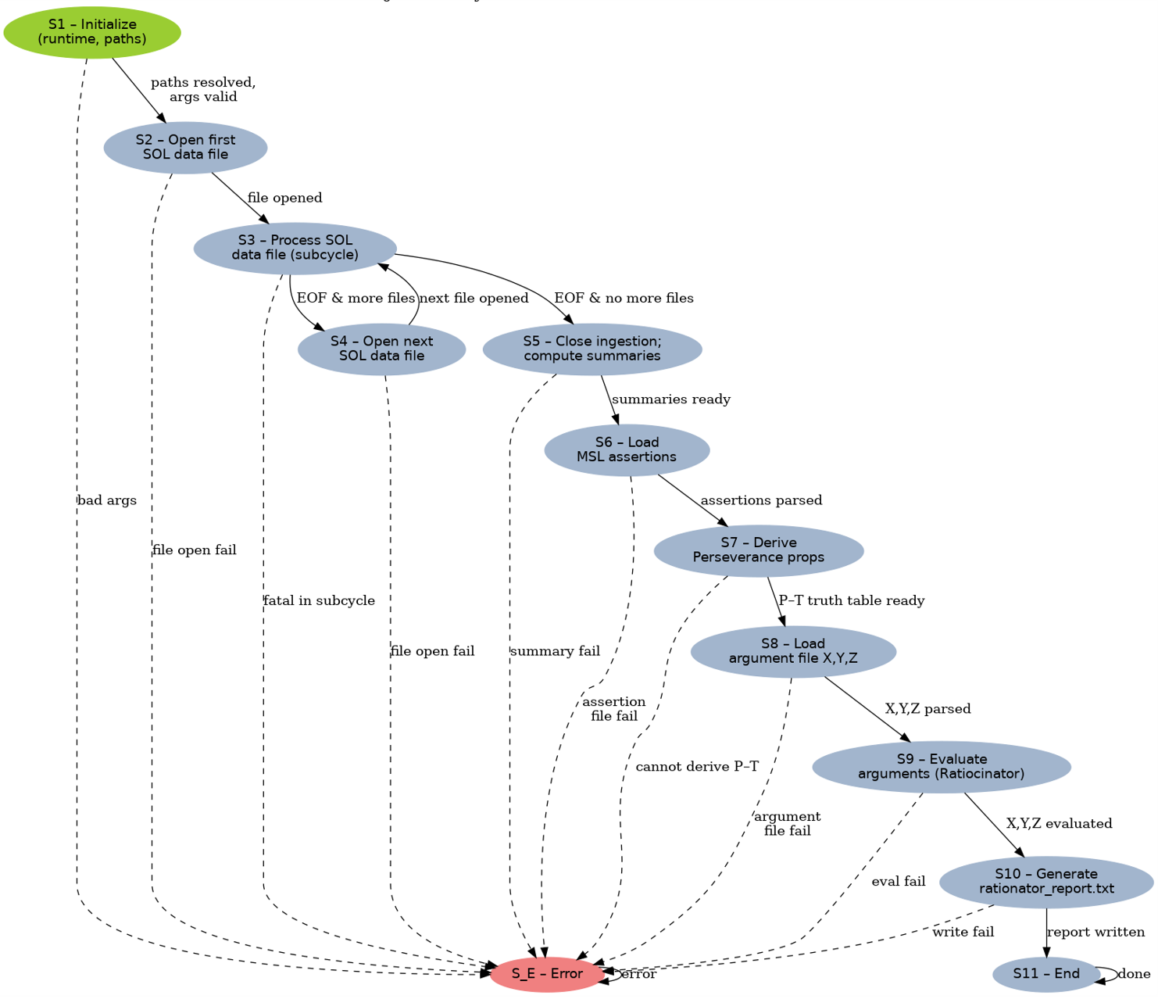

FSD-2 S3 Sub-Cycle

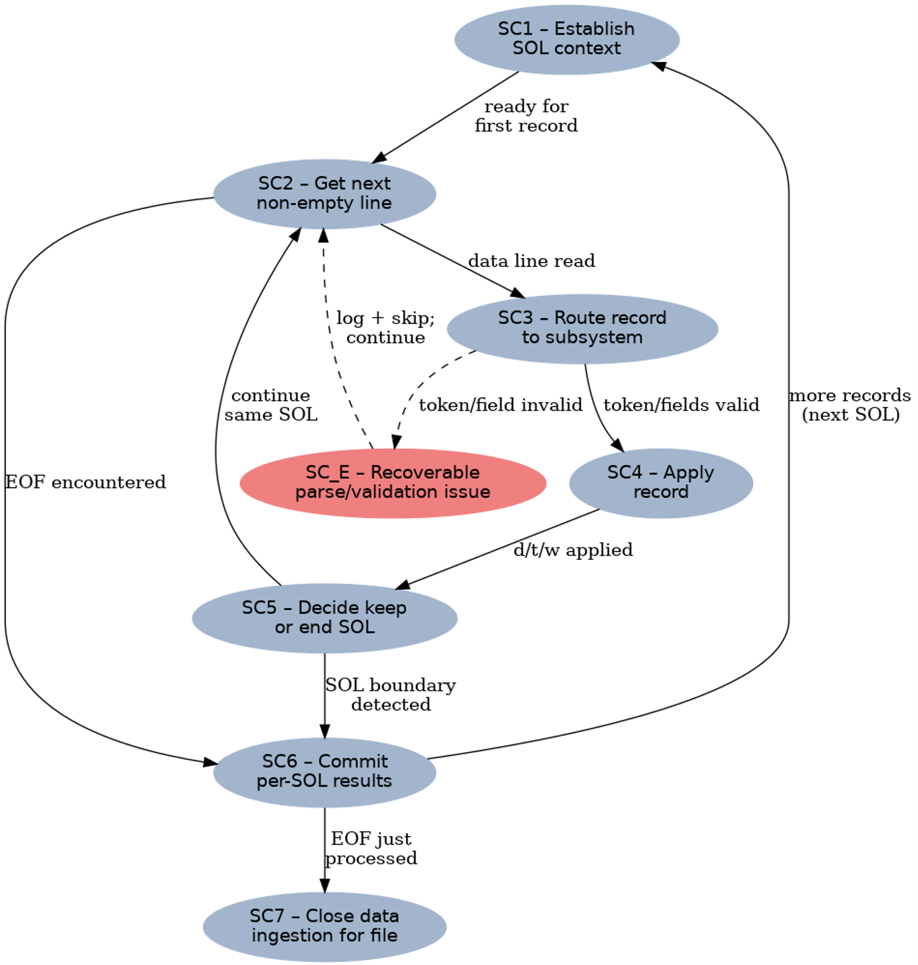

2.3: Mathematical Structure

2.3.1: S, R, O, P – Algebraic Specification Model

S — Sets
- Base Units (Ub): meters (m), seconds (s), kelvin (K). (Other SI bases exist in the library but are not used in this project.)
- Prefixes (Pfx): standard SI prefixes (e.g., nano to kilo for distance; second, minute, hour, sol for time; Celsius and Kelvin for temperature).
- Constant: one Martian sol is taken as 88 775.244 seconds.
- Dimensions (D): Distance (m), Time (s), Temperature (K), Wavelength (m), Angle (dimensionless, expressed in degrees).
- Units (U): each unit is a dimension paired with a scale (e.g., kilometer is Distance with scale ×1000; minute is Time ×60; Celsius is Temperature shifted by +273.15 to Kelvin).
- Quantities (Q): a real number with a unit (e.g., 25 m; 1.5 hr; −62 °C; 520 nm; 179.8°).
- Directions (Dir): {Right, Left, Forward, Backward}.
- Samples (Samp): triples (wavelength, intensity, SOL index).
- Subjects / Species (Subj): finite set of domain entities referenced in propositions, including at least {water, methane, oxygen, hydrogen, temperature, distance}.
- Classifications (Cls): A function $Cls:E→\text{Bag}(\text{Band}×\text{Level})$that, for each encounter $e∈E$, returns a bag (multiset) of Band–Level labels, where Band ∈ {UV, Visible, NIR, IR, Radio} and Level ∈ {Low, Med, High}.
- Seasons (Sea): {Spring, Summer, Fall, Winter}; determined by partitioning each 687-SOL Martian year into four equal quarters.
- Daily Displacement (Disp): Triples (R, θ, T) where R is magnitude of travel in meters, θ is travel direction in degrees, and T is total time in seconds for that SOL.
- Planet (Pl): immutable constants & helpers for Mars (e.g., sol length, season mapping).
- Proposition Labels (PLab): Finite set of atomic labels, at minimum {P, Q, R, S, T}. Each label L identifies exactly one proposition line in the MSL assertion file and the corresponding measurement-derived proposition for that label. The concrete meaning of each label (e.g., a particular water-detection threshold or temperature condition) is determined by the predicate and parameters in those propositions.
- Logical Connectives (Conn)
{¬, ∧, ∨, →, (, )} plus assignment = for defining X, Y, Z.
- Truth Values (TV)
{True, False, Unknown}.
- Propositions (Prop): Atomic formulas over subjects and numeric thresholds, of the forms:
  - detected(s, k) - a subject s ∈ Subj meets or exceeds a threshold k (e.g., detected(water,500) for intensity, or detected(water,100m) for distance).
  - all(s, k) - all relevant measurements for subject s meet or exceed threshold k (e.g., all(hydrogen,1000)).
  - average(temperature, θ) - a mission-average temperature condition relative to threshold θ (e.g., average(temperature,30c)).
  - not(φ) - logical negation applied to any of the above forms.
Each proposition may be tagged by a label in PLab (e.g., P, Q, R, S, T) when representing a named premise.
- Proposition Sets:
- MSLPropSet: set of propositions loaded from the MSL assertion file.
- PerPropSet: set of propositions constructed from Perseverance measurements.
- Argument Expressions (ArgExpr): Well-formed formulas over PLab using Conn, e.g.
- X = (P ∧ Q) → ¬S,
- Y = R ∨ (P ∧ T),
- Z = ¬(S ∨ P).
- Truth Assignments (Assign): Mappings τ : PLab → TV giving a reconciled truth value for each of P, Q, R, S, T.
- Argument Truths (ArgTV): Mappings σ : {X, Y, Z} → TV resulting from evaluating each ArgExpr under τ.

R — Relations
- Dimension Equality: Two units refer to the same dimension if their base dimensions match.
- Unit Compatibility: Addition and subtraction are defined only for quantities of the same dimension.
- Magnitude Ordering: Quantities can be ranked once expressed in a common unit for their dimension.
- Axis Mapping: Right = +x, Left = −x, Forward = +y, Backward = −y.
- Season Mapping: Each SOL belongs to exactly one season via the equal-quarter partition of the 687-SOL Martian year.
- Per-SOL Limits: At most one distance record, one temperature record, and twelve wavelength records per SOL.
- Global Caps:
- Temperature subsystem retains at most 10 stored values while still representing the full sequence statistically.
- SHERLOC/SUPERCAM classifier retains at most 9 unique labels, each unique by its text label.
- SHERLOC/SUPERCAM Uniqueness: No two stored classifications share the same label; if a label already exists, new occurrences do not create additional entries.
- Proposition Equivalence / Opposition: For p, q ∈ Prop,
- p ≡ q if they have the same predicate form, the same subject in Subj, and the same numeric parameters (e.g., both are detected(water,500)).
- q is the negation of p if it is syntactically not(p) or is logically equivalent to not(p) (e.g., not(detected(water,500)) vs detected(water,500)).
- Agreement / Disagreement / Disjointness: For each label L ∈ PLab, let p_M ∈ MSLPropSet, p_P ∈ PerPropSet be the propositions tagged by L (if present).
- They agree when p_M ≡ p_P.
- They disagree when one is the logical negation of the other.
- They are disjoint when they do not share a common subject/predicate pair (they talk about unrelated things).
- Truth Mapping Relation: From $(p_{M},p_{P})$for a label $L$, the reconciled truth assignment $τ(L)∈TV$is determined by:
- If both $p_{M}$and $p_{P}$exist and are structurally equivalent (same form, subject, parameter kind, numeric value, and same negation flag), then
→ $τ(L)=\text{True}$.
- If both exist and are structural negations of each other (same form, subject, parameter kind, numeric value, but opposite negation flags), then
→ $τ(L)=\text{Unknown}$(conflict).
- If only Perseverance has a proposition $p_{P}$:
- if $p_{P}$is non-negated, then $τ(L)=\text{True}$;
- if $p_{P}$is negated, then $τ(L)=\text{False}$.
- If only MSL has a proposition $p_{M }$and Perseverance has none, then
→ $τ(L)=\text{Unknown}$.
- If neither $p_{M}$nor $p_{P}$exists, then → $τ(L)=\text{Unknown}$.
- Satisfaction Relation (⊨): For a truth assignment τ and an argument expression φ ∈ ArgExpr,
- τ ⊨ φ gives a truth value in TV by interpreting
- ¬, ∧, ∨, → with a fixed 3-valued logic over TV.
- Determinism Relation: Given a fixed measurement dataset, fixed MSL assertion file, fixed argument file, and fixed classification thresholds, there is a unique τ and a unique σ produced by the system.

O — Operations
1) Measurement and Unit Conversion
- Normalize Quantities:
- Distances and wavelengths → meters.
- Times → seconds (using 1 sol = 88 775.244 s).
- Temperatures → Kelvin (K = C + 273.15); Celsius forms recovered by C = K − 273.15.
- Angles expressed in degrees in [0°, 360°).
- Validation: Check that each input token corresponds to a known unit and dimension; reject or log-invalid otherwise.
2) Daily Vector Composition (Navigation)
- For each SOL, up to four moves: (distance, direction, time) :
- Convert distance to meters, time to seconds.
- Map direction to axis signs: dx = ±distance, dy = ±distance via the axis mapping.
- Compute day’s net travel: R = √(Fₓ² + Fᵧ²), θ = atan2(Fᵧ, Fₓ) normalized to [0°, 360°).
- When R = 0, define θ = 0° by convention.
- Store each SOL’s (R, θ, T) as a Disp in a mission-level container with capacity ≤ 1374 entries.
3) Streaming Temperature Statistics (REMS)
- Temperatures are normalized to Kelvin on ingest.
- Maintain streaming statistics over all K values:
- Mean: arithmetic average of Kelvin sequence.
- Median: central value with equal counts above and below (two-heap or equivalent)
- Three highest and three lowest: maintained and presented in ascending order within each group
- Seasonal minima: for each of the two summers and two winters, track the lowest
Kelvin; report the lower summer min and lower winter min.
- Expose summaries in both Kelvin and Celsius for reporting and for evaluating the T proposition (“average temperature always −25 °C”).
- Respect the 10-value storage constraint by storing only representative values needed to reconstruct these statistics, not the full sequence.
4) Spectral Classification of Samples (SHERLOC/SUPERCAM)
- Normalize each sample’s wavelength to meters.
- Bands by wavelength:
- UV if λ < 400 nm;
- Visible if 400–700 nm;
- IR if λ >700 nm;
(Additional bands such as NIR or Radio may be modeled but are not used by the current classifier.)
- Assign intensity level from scalar intensity:
- Low if intensity ≤ 100
- Med if 100 < intensity ≤ 500
- High if intensity > 500
Combine band + level into a label Band-Intensity (e.g., Visible-Med).
- When a new label is encountered:
- If not yet stored and total stored labels < 9, store (label, first-encounter SOL) in a stack-like structure.
- If label already present or cap reached (9 labels), do not add another entry.
- At report time, list stored labels in reverse encounter order (most recently discovered first), along with their SOLs.
5) Construction of MSL Propositions
- Parse Assertion File:
From each MSL assertion line, extract:
- Label ∈ PLab (e.g., P, Q, R, S, T, or other letters).
- Predicate form ∈ {detected, all, average, not(…)} as defined in Prop.
- Subject(s) in Subj (e.g., water, methane, hydrogen, temperature, distance) and the associated numeric parameter (intensity, distance, or temperature threshold).
- Build a Prop instance for each line and insert into MSLPropSet.
- Mark the propositions whose labels are P, Q, R, S, T.
6) Construction of Perseverance Propositions
- Use mission-level summaries from Navigation, REMS, and SHERLOC/SUPERCAM to derive measurement-based propositions that mirror the assertion forms for each label in PLab. Examples (illustrative):
  - Q: a measurement-derived detected(water,500) using spectral intensity data.
  - R: a measurement-derived all(hydrogen,1000) using spectral intensity data.
  - S: a measurement-derived detected(water,100m) combining distance traveled and water-related spectral detections.
- T: a measurement-derived average(temperature, θ) using TemperatureStats.
For each label $L∈\{P,Q,R,S,T\}$, construct a data-driven proposition in PerPropSet that:
- uses the same logical form, subject, and numeric parameter as the corresponding MSL assertion for $L$(when it exists), and
- encodes agreement or disagreement with the rover data via a negation flag: the proposition is non-negated when the data supports the assertion and negated when the data contradicts it.
7) Reconciliation of Propositions (Truth Assignment)
- For each label L ∈ PLab:
- Find p_M (MSL proposition) and p_P (Perseverance proposition) if they exist.
- Determine relation: agree, disagree (negation), or disjoint.
- Assign τ(L) ∈ TV according to the truth mapping relation (in R):
    - agree → τ(L) = True
    - disagree → τ(L) = Unknown (conflicting sources)
    - disjoint but both satisfied locally → τ(L) = True
    - missing or inconclusive → τ(L) = Unknown
8) Parsing and Evaluating Argument Expressions (X, Y, Z)
- Parse arguments:
- For each line defining X, Y, Z, split into identifier (X/Y/Z) and infix logical expression over PLab and Conn.
- Tokenize into operands (P–T) and operators (¬, ∧, ∨, →, parentheses).
- Convert to postfix: Use a stack algorithm to convert the infix token stream into a postfix sequence.
- Evaluate: Using τ (truth assignment for P–T), evaluate postfix expressions with a stack:
- Push TV for operands.
- Apply operators according to a fixed 3-value truth table.
- Result is σ(X), σ(Y), σ(Z) ∈ TV.
9) Reporting (Observable Behavior)
- Section 1 - Temperatures: Three highest (ascending), three lowest (ascending), median (C & K), mean (C & K), lowest winter and lowest summer.
- Section 2 – Sample Classifications: Up to nine unique labels with first-encounter SOL, listed last-to-first.
- Section 3 – Distance Traveled: For each SOL with a distance record, the day’s magnitude (m) and angle (deg), optionally total time (s).
- Section 4 – Propositions P-T: For each of P, Q, R, S, T: show MSL proposition, Perseverance proposition, and reconciled truth value τ(L).
- Section 5 – Arguments X, Y, Z: For each argument: show its original expression and final truth value σ(X), σ(Y), σ(Z).

P — Properties
- Closure (numeric and logical)
  - Vector composition produces valid distances (meters) and angles (degrees).
  - Statistical summaries are well-defined on a finite sequence of Kelvin temperatures.
  - Every valid wavelength/intensity pair maps to exactly one classification label.
  - For any total assignment τ : PLab → TV, each argument expression in ArgExpr yields a unique value in TV.
- Compatibility Law
- Addition/subtraction occur only within a dimension; conversions are applied before comparison or combination.
- Logical operators are applied only to truth values in TV; arguments reference only labels in PLab.
- Arithmetic Laws
- Component sums are associative and commutative.
- The direction function uses atan2, ensuring correct quadrants; angles are normalized to [0°, 360°).
- Temperature arithmetic is performed in Kelvin; Celsius values are derived by the affine conversion.
- Seasonal minima and top/bottom lists are invariant under reordering of inputs.
- Logical Laws
- Given fixed MSL assertions and measurement-derived propositions, the reconciliation process yields a single τ (truth table for P–T).
- For fixed τ, evaluation of X, Y, Z is deterministic: same τ → same σ.
- If MSL and Perseverance propositions are both absent or inconsistent for a label L, τ(L) is Unknown.
- Identity Elements
- Additive identities: 0 m for distance, 0 s for time.
- Streaming statistics start with neutral accumulators (zero count and sum).
- Angle is not accumulated; it is derived from components.
- Logical identity: a no-op argument (e.g., X = P) reflects τ(P) without modification.
- Constraints & Caps
- Per SOL: ≤1 distance, ≤1 temperature, ≤12 wavelengths.
- Mission limits: ≤1374 SOL entries for displacement; ≤10 stored temperature values used to represent all stats; ≤9 unique SHERLOC/SUPERCAM labels kept, uniqueness by label.
- Each proposition label in PLab is associated with at most one reconciled truth value in τ.
- Error Handling
- Recoverable issues (e.g., malformed line, invalid or out-of-range unit, extra w beyond 12 for a SOL, repeated classification label when cap reached) are logged and the offending record is skipped; the rest of the data continue to process.
- Exceeding any cap results in the extra items being ignored deterministically.
- Unrecoverable failures (file open failure for a required file, impossible assertion parse, or design-chosen fatal constraint) transition the system into the error state S_E; no normal report is produced.
- Determinism
- With the same measurement files, the same MSL assertion file, the same argument file, and fixed constants/thresholds, the system produces the same rationator_report.txt every run.
- Reverse-encounter ordering for sample classifications and the fixed ordering of sections in the report make the observable output stable and repeatable.

2.3.2: M = {S, I, O, f, g, S₀} – State Machine Model
S — States
The system-level states (top-level FSM) are:
- S1 – Initialize
- S2 – Open first SOL data file
- S3 – Process SOL data file (measurement sub-cycle)
- S4 – Open next SOL data file
- S5 – Close data ingestion; compute measurement summaries
- S6 – Load MSL assertions
- S7 – Derive Perseverance propositions and reconcile P–T
- S8 – Load argument file (X, Y, Z)
- S9 – Evaluate arguments with Ratiocinator
- S10 – Generate rationator_report.txt
- S11 – End
- S_E – Error
While in S3, the machine uses a local measurement sub-cycle FSM with states:
- SC1 – Establish SOL context
- SC2 – Get next non-empty, non-comment line
- SC3 – Route record to subsystem (d/t/w)
- SC4 – Apply record (Nav / Temp / SHERLOC/SUPERCAM)
- SC5 – Decide to keep reading this SOL or end it
- SC6 – Commit per-SOL results
- SC7 – Close data ingestion for this file
- SC_E – Recoverable parse/validation issue
Each state maintains:
- Current file index and SOL index
- Per-SOL flags (hasD, hasT, wCount)
- Mission-level navigation, temperature, and sample summaries
- MSL proposition set, Perseverance proposition set
- Reconciled truth table τ(P…T) and argument results σ(X,Y,Z)
- A log for recoverable issues and a flag for fatal error.

I — Inputs
The inputs to the machine are:
- One or more measurement data files (one per Mars year), each a text file of lines:
  - d, … — distance record for a SOL (up to four moves of distance+unit, direction, time+unit)
  - t, … — temperature record for a SOL (value + unit °C or K)
  - w, … — wavelength sample (wavelength + unit, intensity)
  - Blank lines and comment lines may appear and are ignored.
- A single MSL assertion file containing proposition lines using detected, all, average, and not(...) forms for P, Q, R, S, T and any supporting facts.
- A single argument file defining X, Y, Z as logical expressions over P, Q, R, S, T using connectives (NOT, AND, OR, IMPLIES).
The file paths for these are provided as program arguments and validated in S1.

O — Outputs
The machine produces one report file:
- rationator_report.txt
with sections (order fixed):
- Measurement summaries (per year / mission):
- Temperatures: three highest (asc), three lowest (asc), median (C & K), mean (C & K), lowest winter, lowest summer.
- Sample classifications: up to nine unique band labels (e.g., UV / VIS / IR) with first-encounter SOL, listed last-to-first.
- Distance traveled: for each SOL that had a distance record, the day’s magnitude (m) and angle (deg); optional total time (s).
- Propositions P–T (MSL vs Perseverance):
- For each P, Q, R, S, T: show MSL’s proposition, Perseverance’s data-derived proposition, and the reconciled truth value τ(L) ∈ {True, False, Unknown}.
- Arguments X, Y, Z:
- For each argument: the original expression and its evaluated truth value σ(X), σ(Y), σ(Z) ∈ {True, False, Unknown}.
If a fatal error occurs (S_E), a normal report is not produced; the program may instead emit an error summary.

f — State Transition Function
This function advances the machine through initialization, measurement files, logical reasoning, and reporting.
Normal system-level path:
- S1 → S2 → S3 → {S4 | S5} → S6 → S7 → S8 → S9 → S10 → S11
Where:
- S1 → S2: arguments and paths validated, runtime initialized.
- S2 → S3: first measurement file opened.
- S3 → S4: measurement sub-cycle finishes file with EOF and more files remain.
- S3 → S5: measurement sub-cycle finishes last file (EOF and no more files).
- S4 → S3: next measurement file opened.
- S5 → S6: mission-level Nav/Temp/SHERLOC/SUPERCAM summaries are computed.
- S6 → S7: MSL assertions successfully parsed into propositions.
- S7 → S8: Perseverance propositions derived from data and reconciled with MSL, producing τ(P…T).
- S8 → S9: X, Y, Z parsed from argument file.
- S9 → S10: X, Y, Z evaluated via Ratiocinator using τ.
- S10 → S11: rationator_report.txt written successfully.
Branch / error behavior:
- Any file-open failure (measurement, MSL assertion, or argument file), non-recoverable parse failure, or fatal constraint violation triggers a transition to S_E.
- Once in S_E, the machine logs the error and does not re-enter the normal path; further transitions do not change the state (absorbing error state).
Measurement sub-cycle transitions (inside S3):
- SC1 → SC2: SOL context initialized/reset.
- SC2 → SC3: data line read (non-empty, non-comment).
- SC2 → SC6: EOF encountered for this file.
- SC3 → SC4: record tokenized and classified as d/t/w.
- SC3 → SC_E: line malformed (recoverable).
- SC4 → SC5: record applied to Nav/Temp/SHERLOC/SUPERCAM with per-SOL limits enforced.
- SC5 → SC2: remain in same SOL (more records for this SOL).
- SC5 → SC6: SOL boundary detected; time to finalize this SOL.
- SC6 → SC1: SOL finalized; more records remain (next SOL).
- SC6 → SC7: SOL finalized and EOF processed.
- SC7 returns control to the system FSM, allowing S3 to transition to S4 or S5.
Recoverable error sub-cycle behavior:
- SC_E → SC2: log and skip the bad record, then continue reading; does not cause a system-level S_E by itself.

g — Output Function
The output function g produces observable artifacts at specific states:
- On SC6 (Commit per-SOL results)
  - Compute net displacement for the SOL: R = √(Fₓ² + Fᵧ²), θ = atan2(Fᵧ, Fₓ) normalized to [0°, 360°).
  - Store Disp = (R, θ, T) for that SOL in the mission-level navigation structure.
  - Update SHERLOC/SUPERCAM classification stack and seasonal info as needed.
- On S5 (Close ingestion; compute measurement summaries)
  - Finalize mission-level temperature statistics (mean, median, top/bottom-3, seasonal minima).
  - Finalize mission-level SHERLOC/SUPERCAM band classifications (up to 9 band labels, reverse-encounter order).
  - Finalize mission-level navigation totals and any derived metrics needed for propositions (e.g., distance in first 100 m).
- On S7 (Derive Perseverance propositions)
  - Construct data-driven propositions for P, Q, R, S, T from summaries, using the same predicate forms (detected, all, average, not) as in the MSL assertions.
  - Reconcile MSL vs Perseverance propositions to produce the truth assignment τ(P…T).
- On S9 (Evaluate arguments with Ratiocinator)
  - For each of X, Y, Z: parse expression into postfix, evaluate using τ, and store σ(X), σ(Y), σ(Z).
- On S10 (Generate rationator_report.txt)
  - Write all measurement summaries (Temp, SHERLOC/SUPERCAM, Nav) and logical results (P–T table and X, Y, Z truth values) to the report file in the required order.

S₀ — Initial State
The initial state is:
- S₀ = S1 – Initialize
At S1:
- SOL index and file index are set to 0.
- All subsystems (Navigation, TemperatureStats, SherlocClassifier, Ratiocinator) are cleared.
- Planet constants (1 sol = 88 775.244 s and 687-SOL year partition) are loaded.
- Paths for measurement files, the MSL assertion file, and the argument file are validated before transitioning to S2.

3.0: Engineering Model

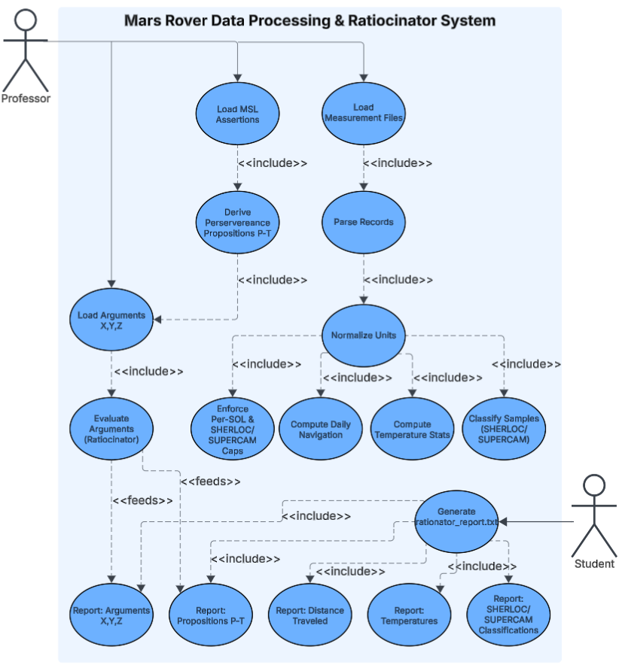
3.1: Use Case Diagram

3.2: Class Relationship UML Diagram
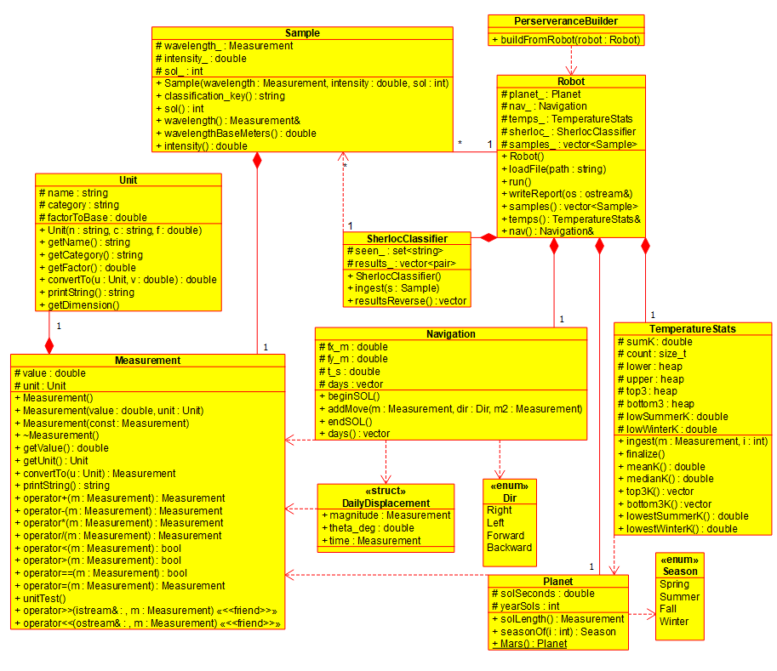
3.2.1: UML-1: Measurement & Rover Layer

Cross-Diagram Connections:
PerserveranceBuilder (UML-1) depends on Proposition, PredicateForm, Subject, and ParamKind (UML-2)

3.2.2: UML-2: Logical Reasoning & Propositions Layer
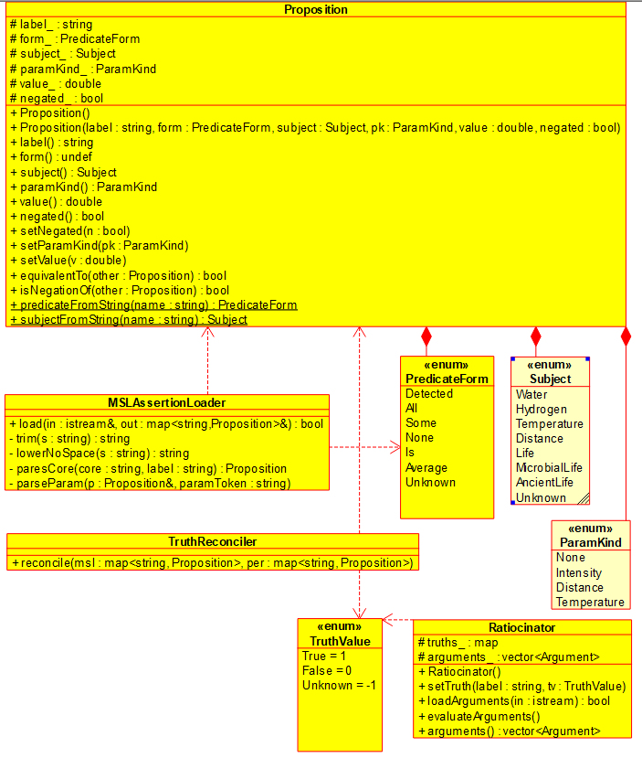

4.0: Application Model
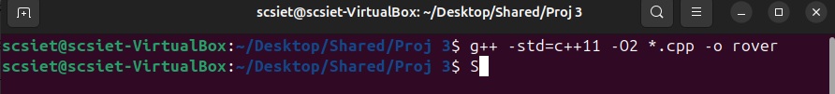
Figure 1 – Code Successfully Compiled

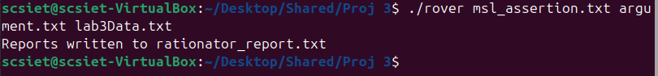
Figure 2 – Example of Program Output to Report File

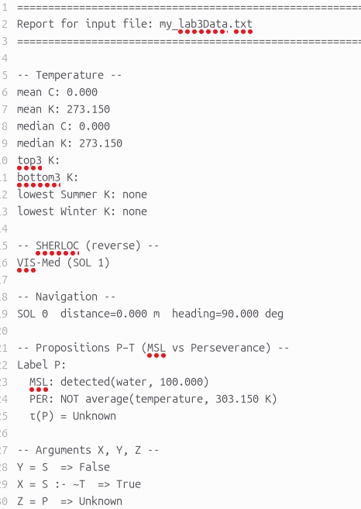
Figure 3 – Sample of Report File (File cut to fit)

5.0: Summary

This implementation closes the loop between raw rover data and clear logical conclusions without hiding any of the steps in between. The measurement side stays grounded in the original Project 2 work: units and dimensions are handled through a shared Unit/Measurement layer, Navigation composes daily displacement from signed moves, TemperatureStats maintains streaming statistics under strict caps, and Sample + SherlocClassifier convert spectral lines into constrained band–intensity classifications. The Robot class ties these pieces together for each SOL file, enforcing per-SOL limits, keeping mission data isolated per run, and exposing clean summaries for navigation, temperature, and spectroscopy. UML Diagram 1 reflects this layer as a compact, mostly-physical model of the rover’s world, with memory and capacity rules baked into the structure instead of buried in magic numbers.
On top of that, the project adds a thin logic layer that sticks closely to the algebraic and state-machine models. MSLAssertionLoader parses MSL’s P–T claims into Proposition objects, PerseveranceBuilder turns the rover’s own summaries into a matching set of data-driven propositions, and TruthReconciler assigns three-valued truth results where they agree, conflict, or are incomplete. Ratiocinator then evaluates the X, Y, and Z arguments using an infix-to-postfix stack evaluator over the resulting truth table. UML Diagram 2 captures this reasoning side separately from the rover mechanics, making it obvious where each requirement lives: caps and bands in the measurement layer, proposition structure in Proposition and its enums, reconciliation in TruthReconciler, and argument evaluation in Ratiocinator. The final result is a system where the report file isn’t just “some output”—it’s the visible surface of a pipeline that matches the math and engineering models almost line for line.

6.0: Notes

